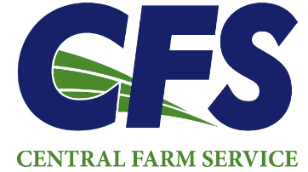 | Sales Representative:  Brandon O’Connell  boconnell@cfscoop.com  (507)560-3280 | Energy Accountant  Amber Roeker  aroeker@cfscoop.com  (507)676-3549

Dear Central Farm Service Customer:
Thank you for choosing us as your heating fuel supplier this past season. We appreciate your trust and look forward to continuing to serve your home heating needs.
Please take a moment to review the enclosed information to help you make an informed decision for the upcoming season. To discuss pricing, options, and completing your 2026 - 2027 contract, please contact your sales representative listed above.
Below are some key points regarding contracts for the upcoming season:
- Home Heat Prepaid Contracts will begin on September 1st, 2026, or on the start date noted in the contract, and will expire on April 15th, 2027.
- Budget Contracts will start on September 1, 2026, and expire on April 15th, 2027. All budget contracts will be paid via ACH and pulled on the 20th of each month. Budgets typically start June 1st, this year will be different with the July 1st new ownership.
- When a customer has multiple Home Heat Contracts, the oldest contract must be delivered first.
- Clear Access to Propane Tanks: Customers are required to maintain a clear path to their propane tank year-round, especially during winter months when snow removal is necessary.
To ensure the lowest possible monthly payments, Budget Contracts should be set up before the end of August.
Prepay Contracts can be set up year-round.
Customers in good standing are not required to sign a contract and can pay for fuel as it is delivered, according to our normal credit terms.
If any changes have occurred that may affect your propane usage next year, please contact us so we can factor these into our scheduled delivery calculations, including the current propane level in your tank.
Please note that credit card payments for any of these programs will incur a 3% processing fee. All contracts are subject to Central Farm Service’s credit terms and policies.
Thank you again from all of us at CFS Energy. We value your business and are here to assist with any questions or concerns you may have.

Steve Scholtz, VP Energy Amber Roeker, Energy Accountant Brandon O’Connell
Central Farm Service Central Farm Service Sales Representative

Please see our enclosed delivery and payment policies.

