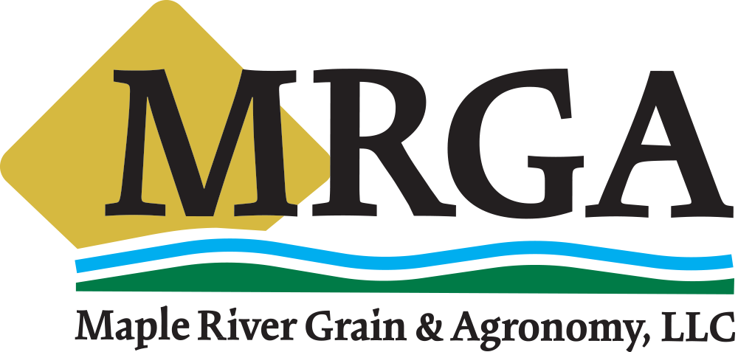

Fee Increases
Effective January 3rd, 2022

Due to an increase in fees from North Dakota Grain Inspection, Maple River Grain & Agronomy, LLC will be increasing the inspection fee for each probed sample brought into Casselton from the current $10, to $13 per probed sample.
Submitted samples will be charged per the North Dakota Grain Inspection rate at the time of submittal.
There will be a change to MRGA Freight Spreads. All locations will now be at 8 cents off the Casselton bid, with the exception of Rothsay, which will retain its own bids independent of Casselton’s. These are subject to change.
Trucking rates have increased as well, please see the Trucking Rates on our website.

If you have any questions, please reach out to one of our Grain Department members.
Kim Bender: 701-347-3129
Tanner McDaniel: 701-347-3138
Chad Priewe: 701-347-3143

